**Nitin Pachauri**

**53 (B)**

**2315001514**

Assignment-1 (Mongodb Queries)

# Find / Query Operations

1. Find the names and CGPAs of all students from the "IT" department.

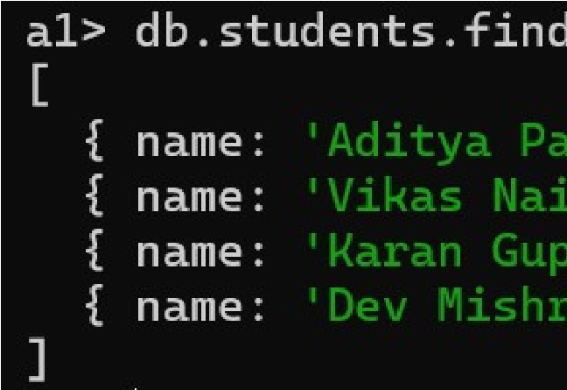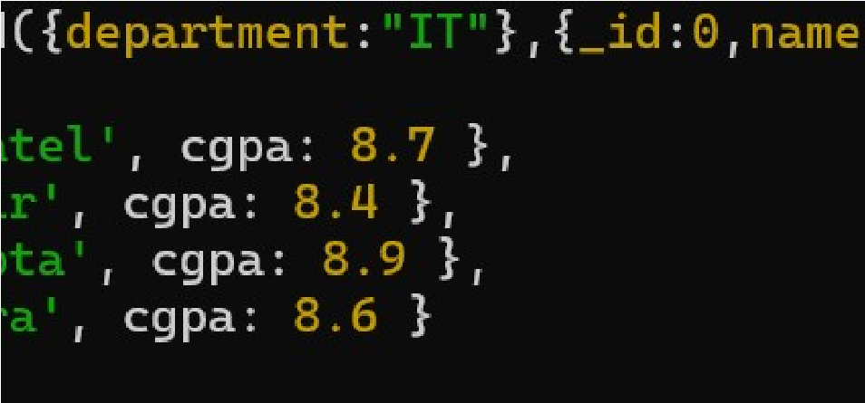

1. List all students whose CGPA is greater than or equal to 8.5. Show only their name, roll number,and department.

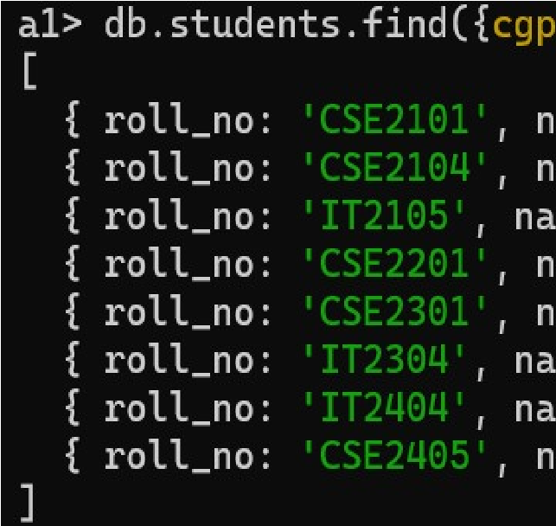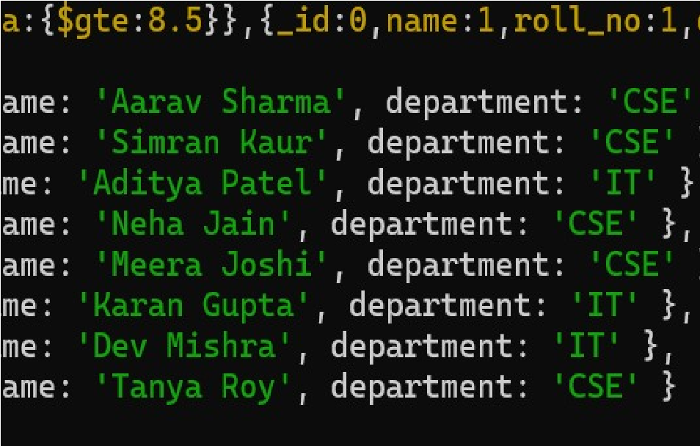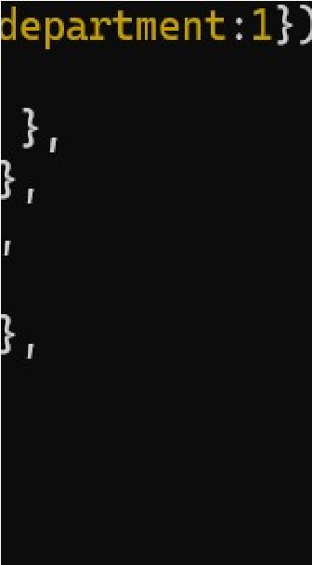

1. Find students who are in either the "ECE" or "ME" department using $in.

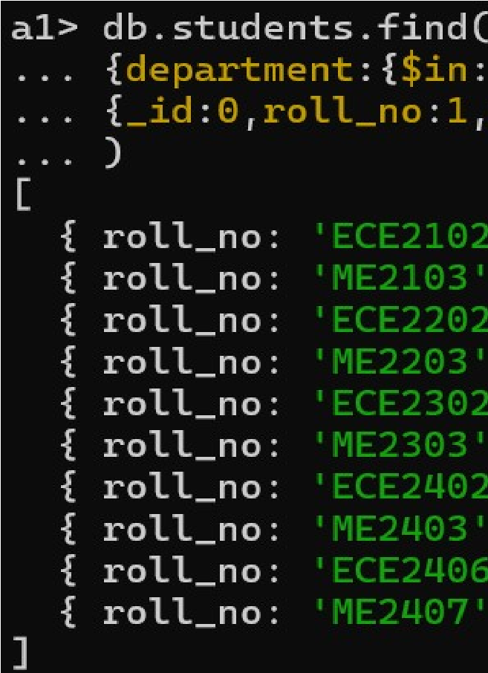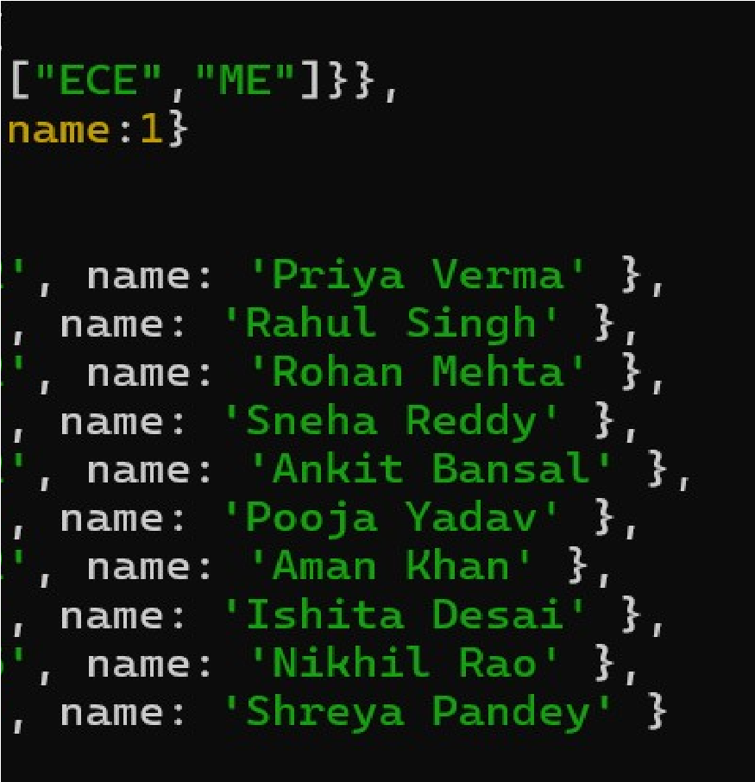

1. Get the name and CGPA of students who are in the 4th year and have a CGPA greater than 8.0.

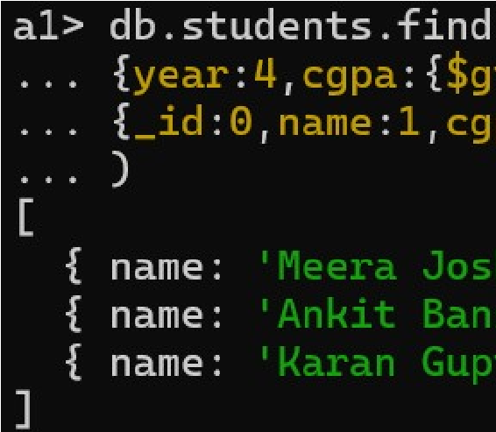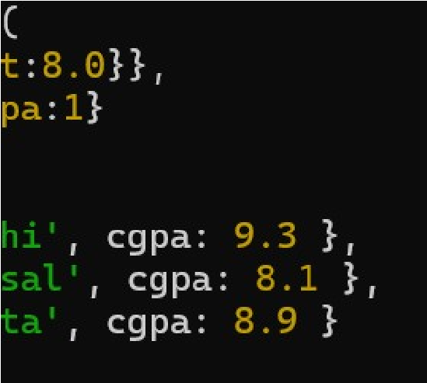

1. Find all students who are not in the "CSE" department and have a CGPA less than or equal to 7.5 using $and and $ne.

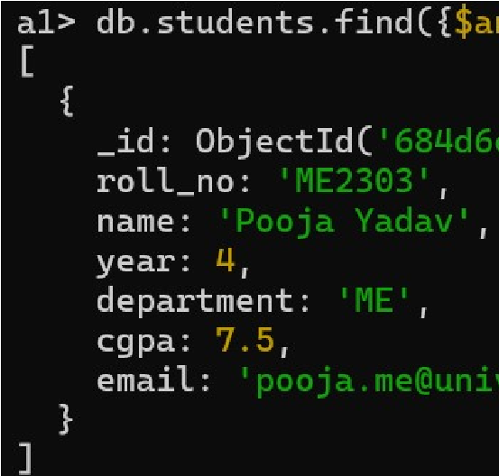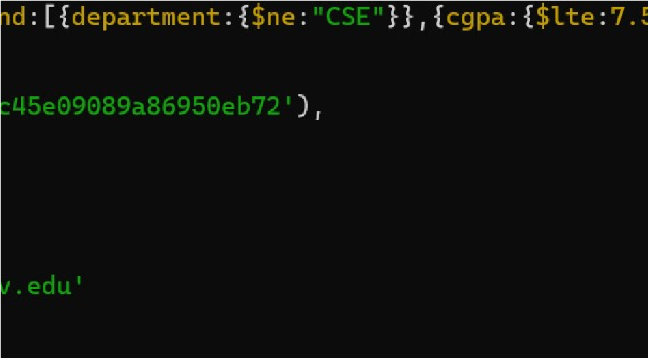

# Sort / Pagination

1. Display the top 3 students with the highest CGPA across all departments.

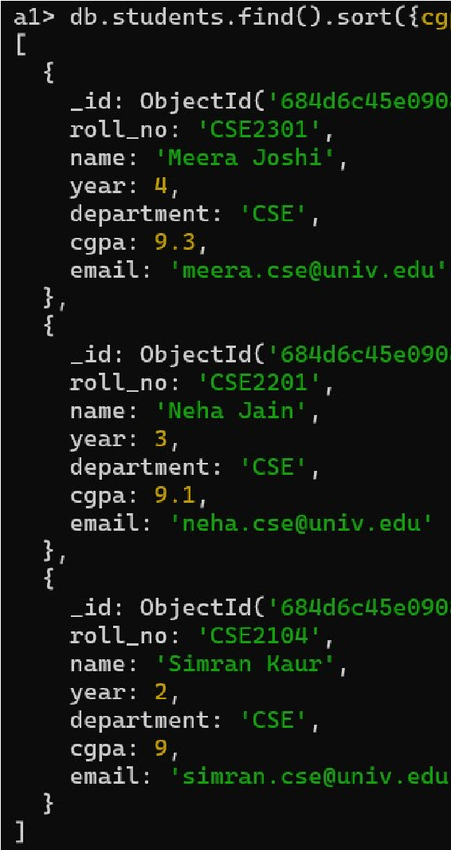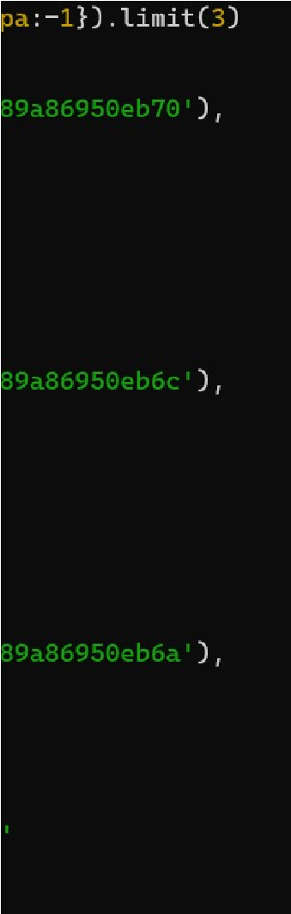

1. Show the next 3 students after skipping the top 3 based on CGPA(pagination).

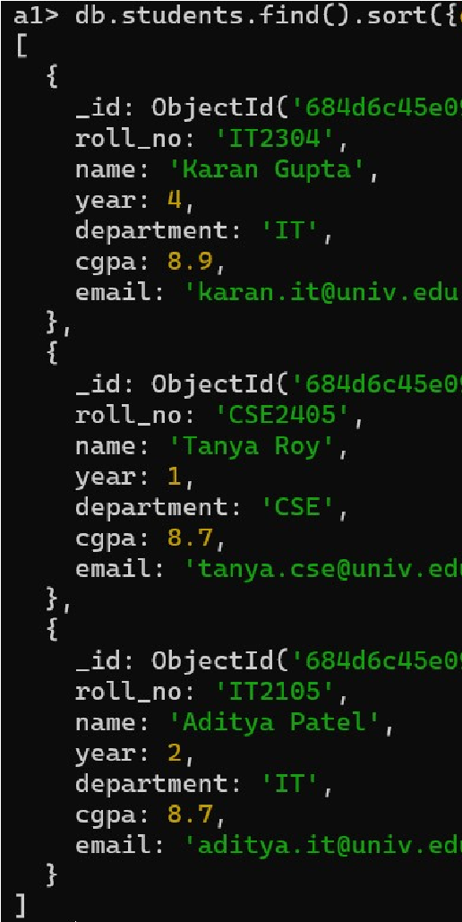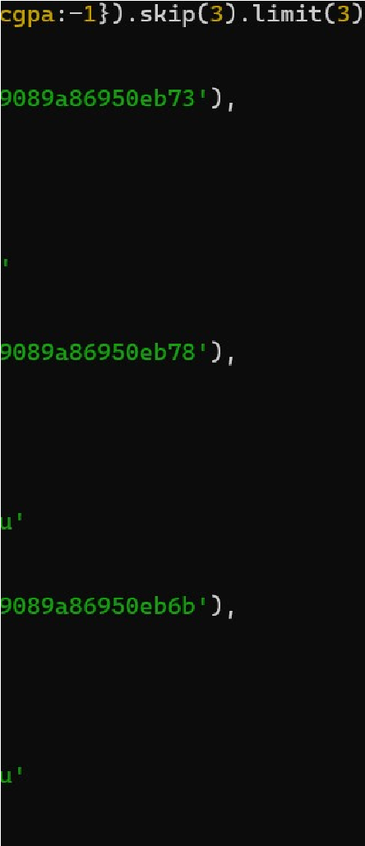

# Update Operations

1. Increase the CGPA by 0.2 for all students in the "CSE" department.

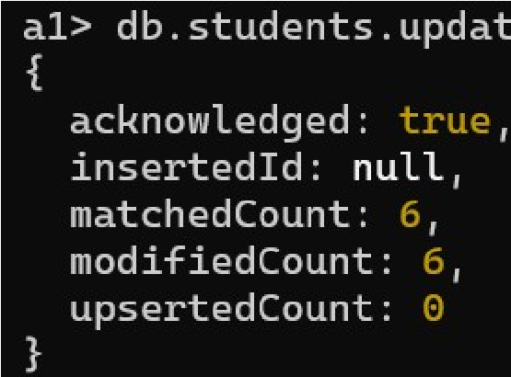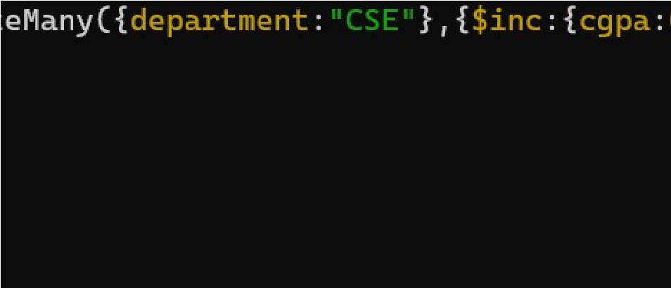

1. Set the department to "Probation" for all students with CGPA less than 7.0.

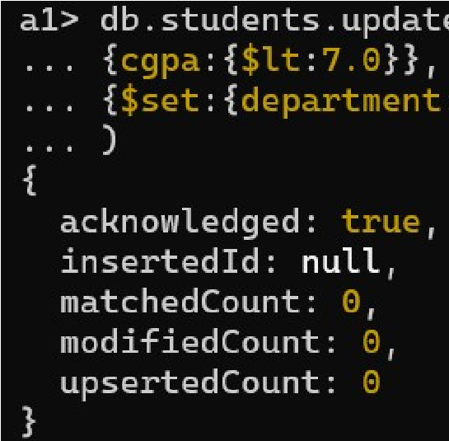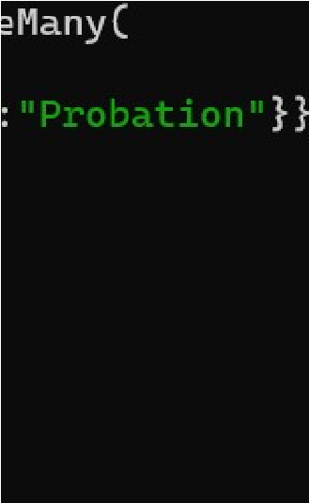

1. Remove the email field from all students in the "ME" department.

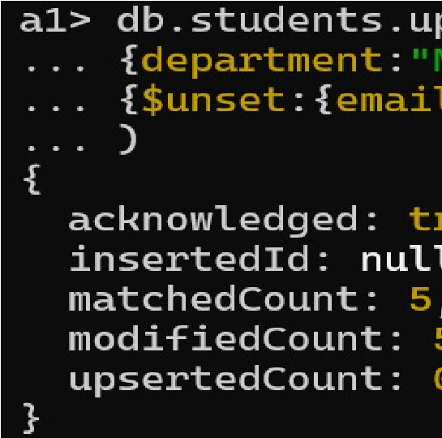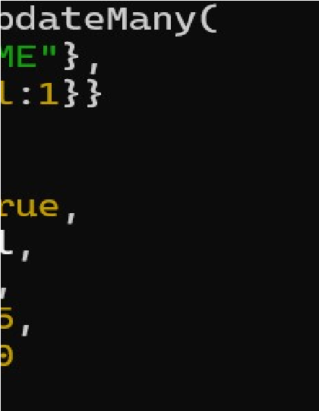

# Bonus (Advanced)

1. Rename the field cgpa to gpa for all students.

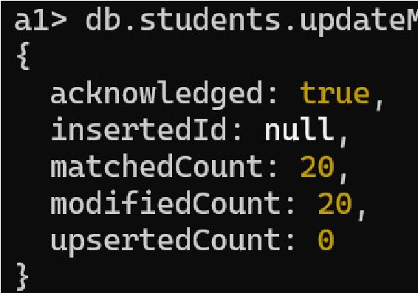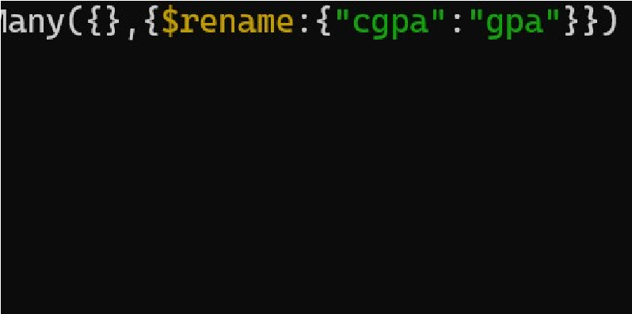

1. Replace the entire document of a student with roll number "CSE2104" with a new record containing updated values.

